# Aws site to site connection

# .steps: 1st in Mumbai region we create a vpc in name (aws-site)

# Vpc

# Subnet

# Internet gateway

# Route table ( route & subnet association)

# Vpc done.

# Step 2. In singapur region we create a vpc name (custmor-site)

# Vpc

# Subnet

# Internet gateway

# Roue table ( add route & subnet association)

# In singapore region we launch an ec2 instance :

# Launch instance name ( custmor-site)

# In network security ( edit and choose our vpc and subnet & port add ssh, all tcp , icmp . anyware)

# Now we come back in Mumbai region and go in vpc ….

# Go in virtual private network and create ( virtual private gateway) & attach to vpc

# Create custmor gateway and their we put (public ip of singaure region ec2 instance ,,,,// custmor-site)

# We create site to site connection click on and ( Mumbai-singapore ) and their we put subnet ip of Singapore region (10.2.0.0/24

) and aws automatically their create 2 tunnels

# And download configuration of site to site connection (

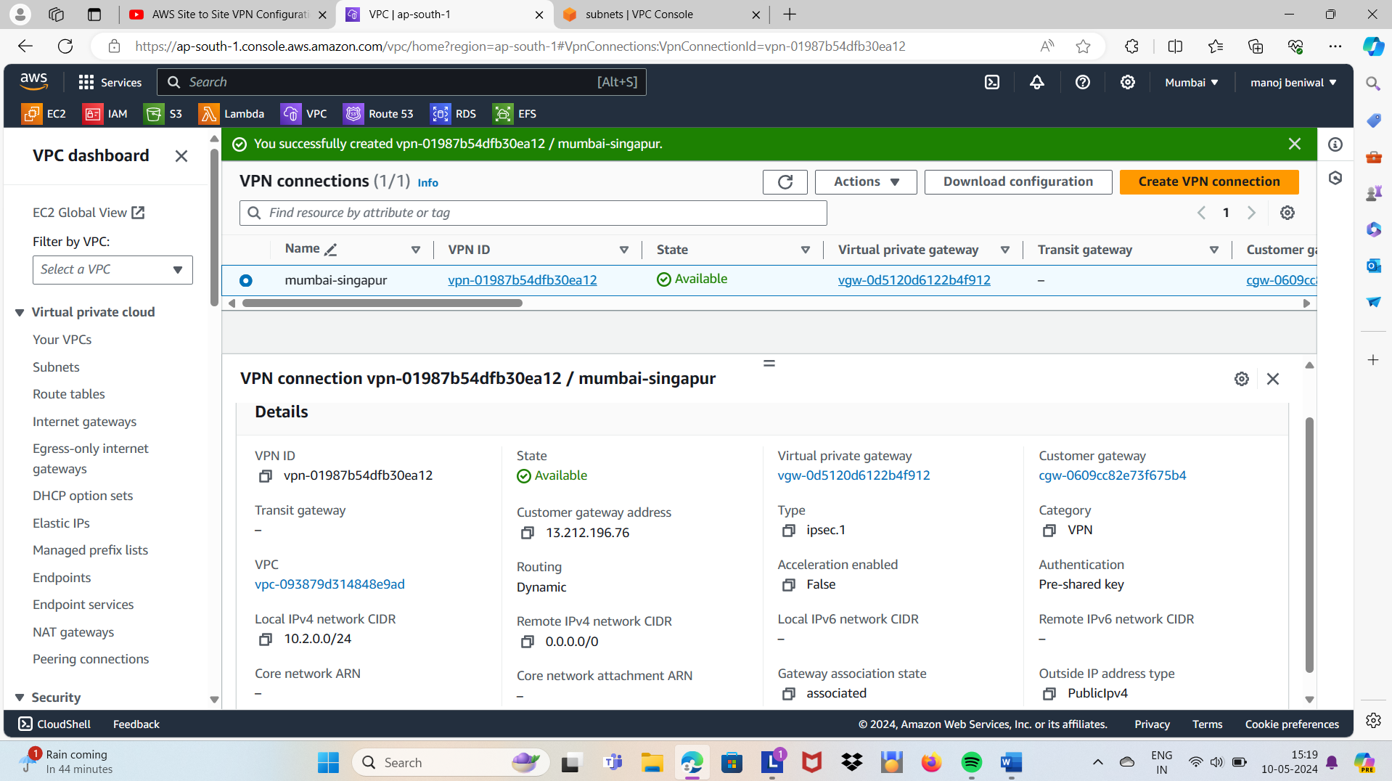

# Show tunnel details : its showing down after that its up so sucessfully

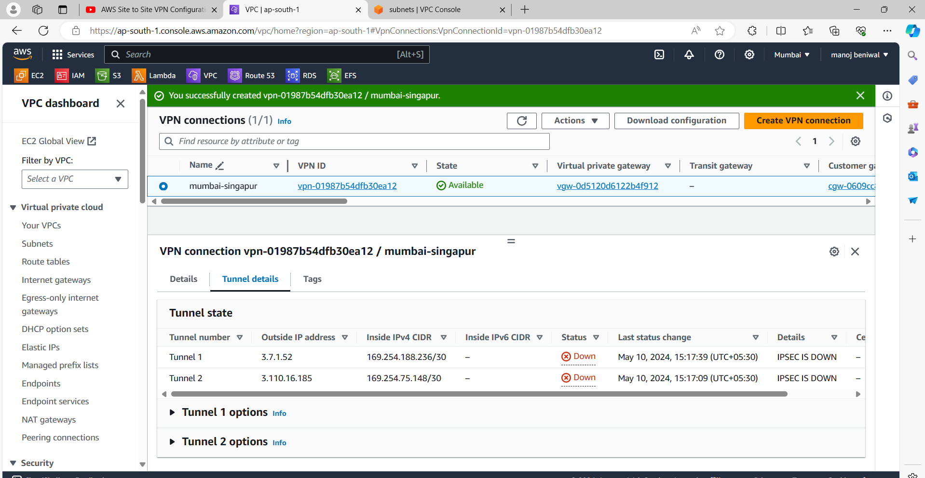

# Now we go back our route table and click on route propragation and cchoose their : in ss

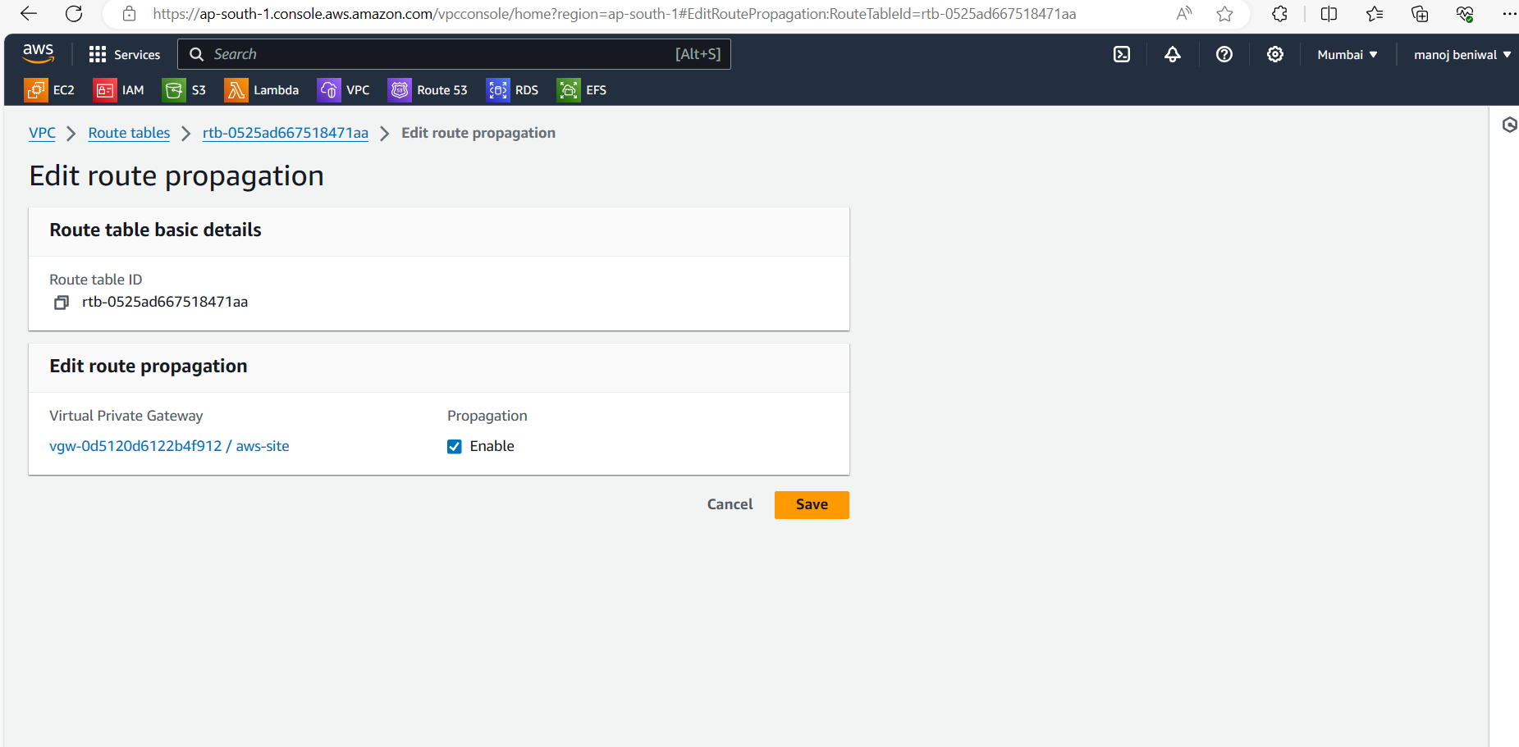

# Now we go back in Singapore ( custmor-site ) and in ec2 instance select instance and copy public ip and go on putty gen and put public ip their and create a key and connect instance via putty and run commands:

# Ec2-user and enter